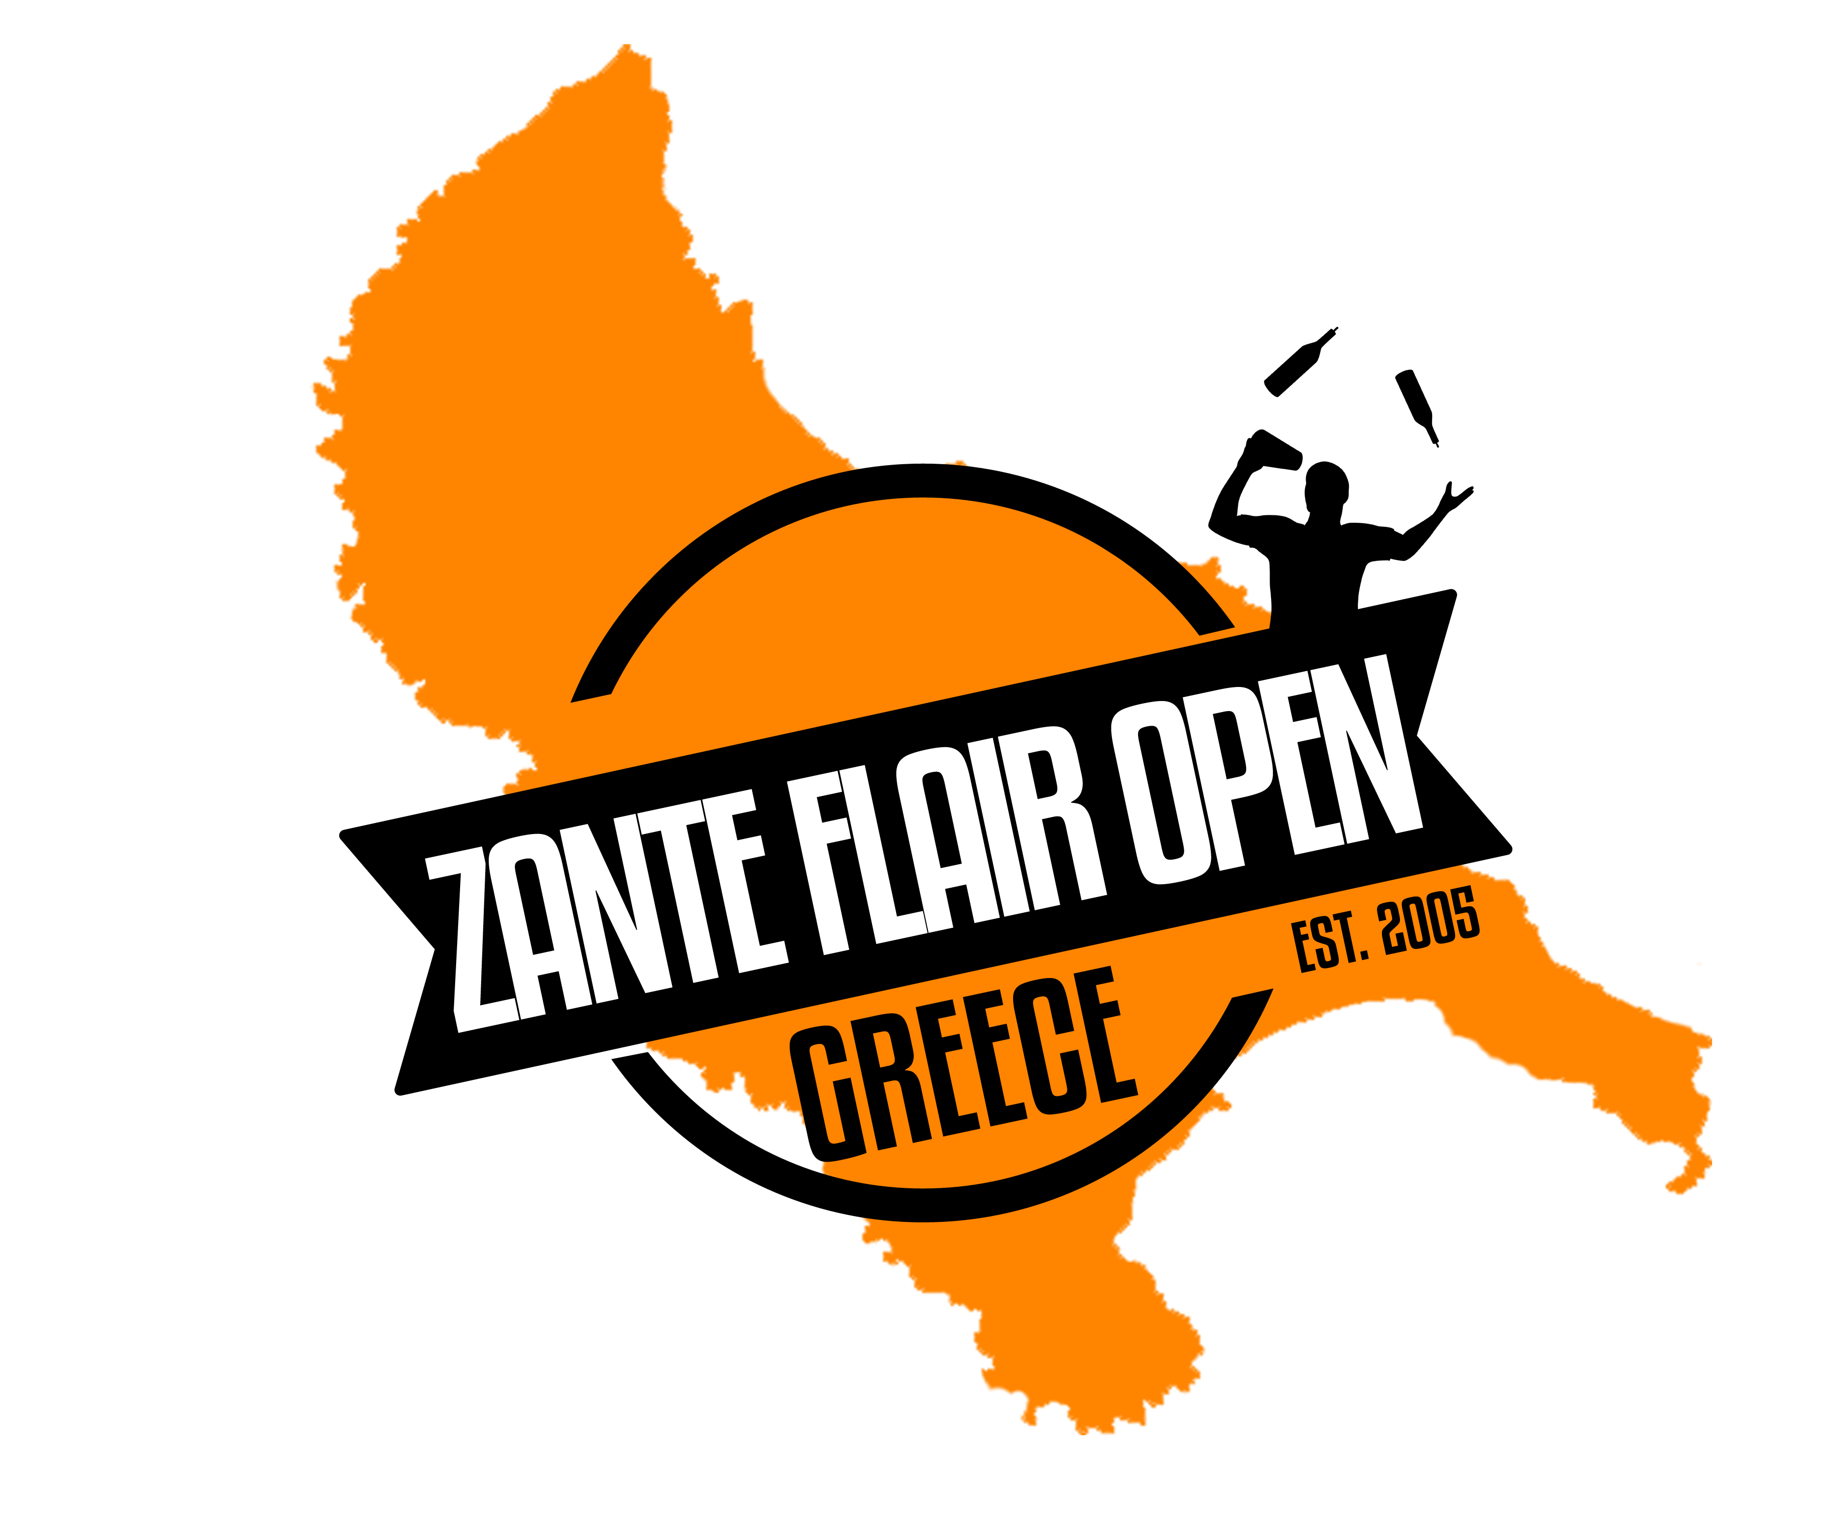
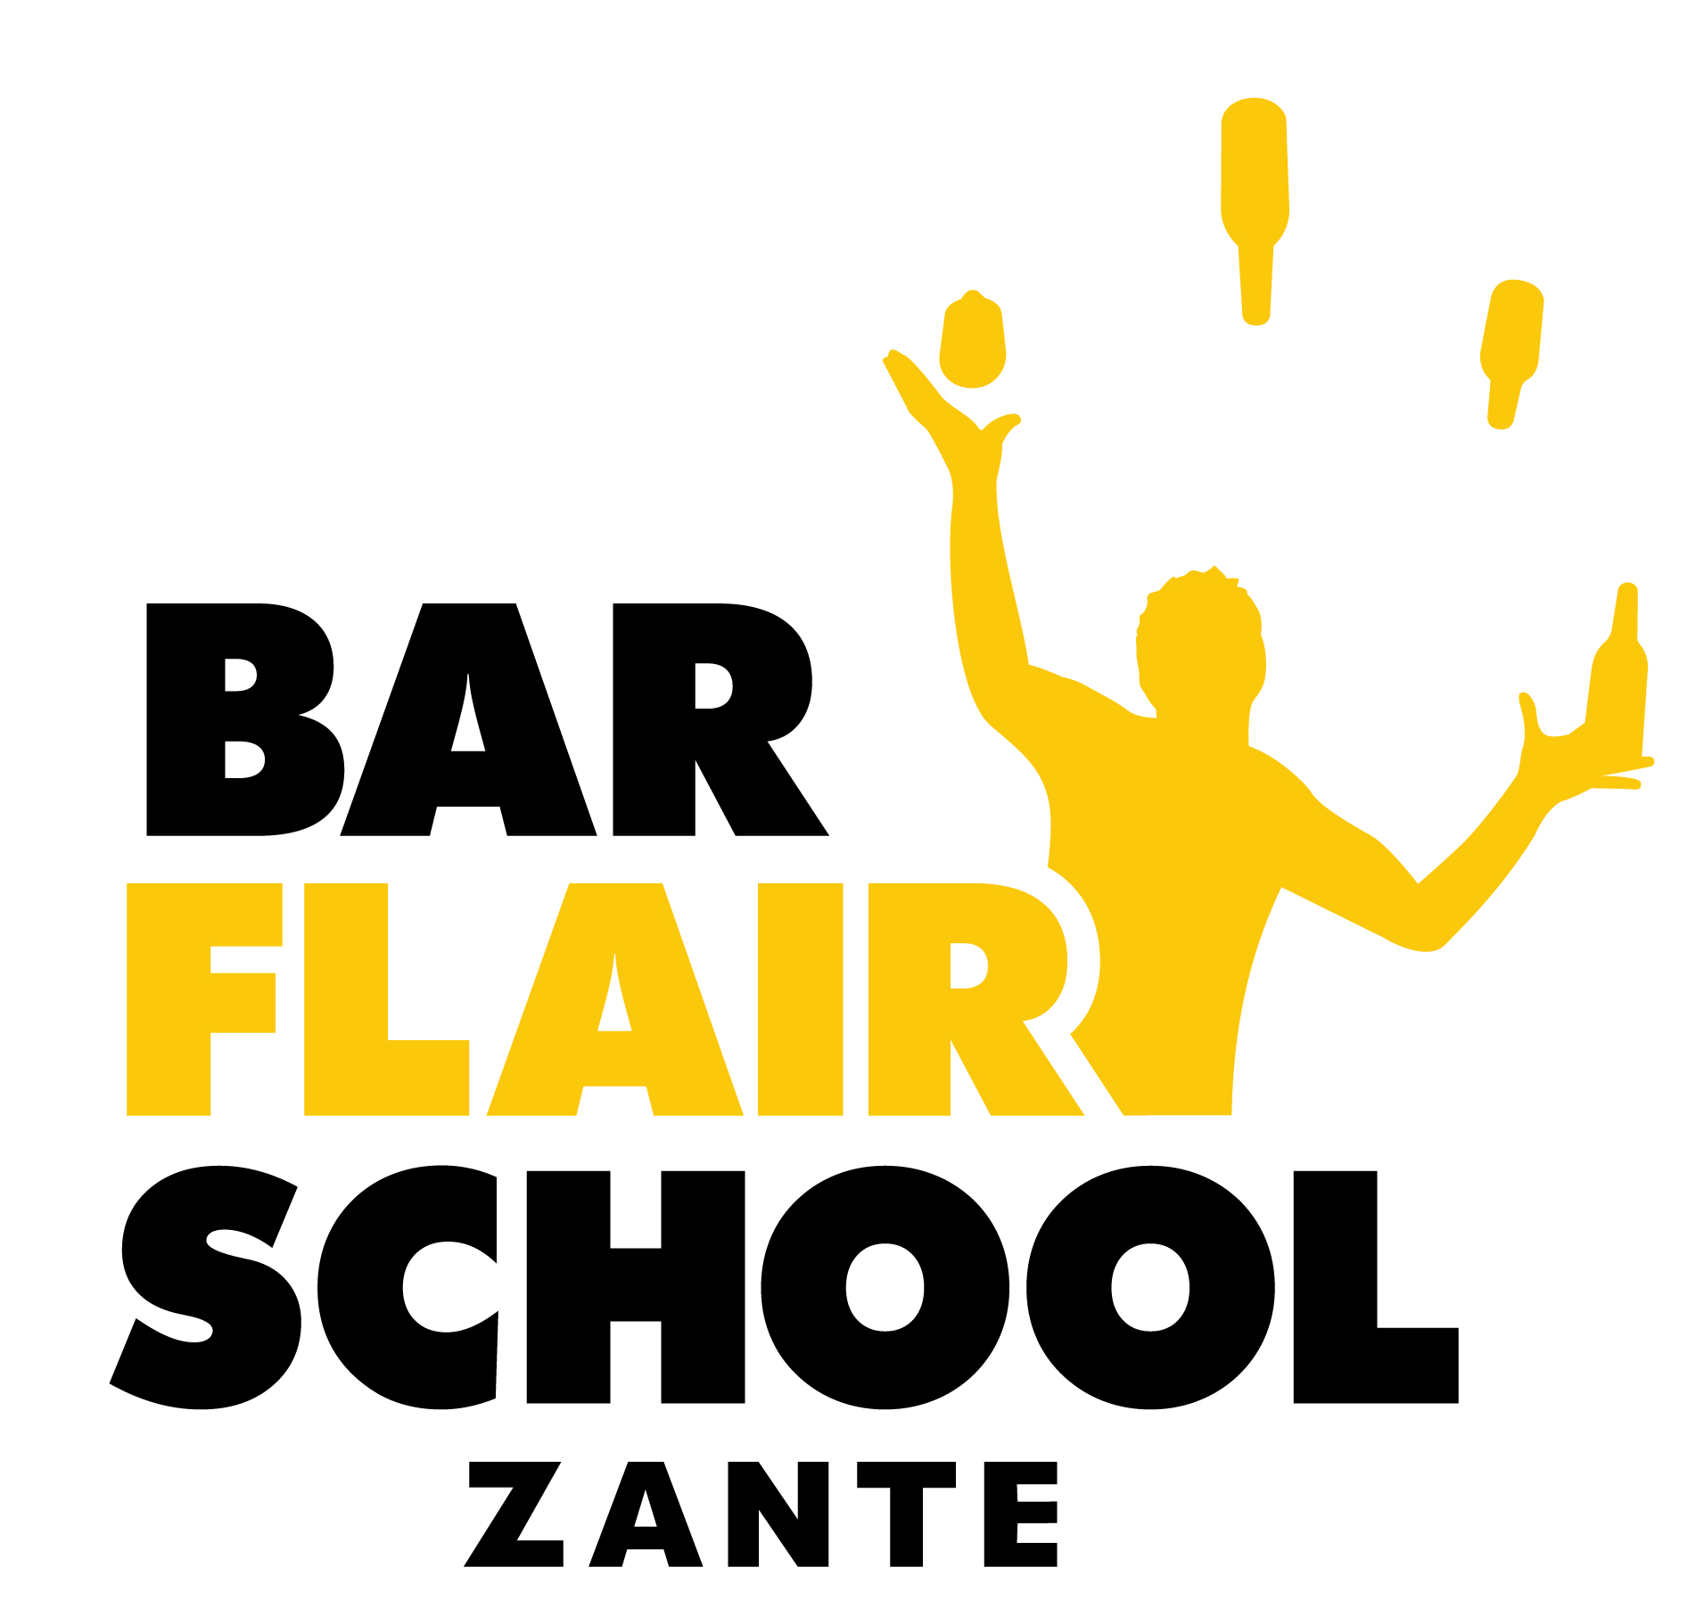
ZANTE FLAIR OPEN 2018
COMPETITOR COCKTAIL RECIPE

Competitors must complete the following form detailing their cocktail recipe.
- Please type in the boxes.
- Save the document as “Your name cocktail recipe”, so for example “Dennis Kalogerias cocktail recipe”
- Save document as a PDF
- Email info@barflairschool.com with the document attached and the email subject line “’YOUR NAME’ cocktail recipe”, so for example “Dennis Kalogerias cocktail recipe”
- Please ensure you email us this form by SUNDAY 20TH MAY 2018.

Competitor Name:

Cocktail Name:

Cocktail Ingredients & Amounts:
Garnish:
Notes:
(Optional)

